 City Gates

Android Mobile Application v1.0 User Manual

JayBalunan and Ma.Nelle Yap

BS Computer Science 4

University of San Carlos

Table of Contents

Getting Started 2

Knowing City Gates 3:

I. Getting Started 2

II. City Gates Homepage  3

III. About City Gates  3

IV. Meet Our Pastors  3

V. Sunday Celebration  3

VI. Contact Us 3

Table of Figures

Getting Started 2

Knowing City Gates 3

I. Getting Started 2

II. City Gates Homepage  3

III. About City Gates  3

IV. Meet Our Pastors  3

V. Sunday Celebration  3

VI. Contact Us 3

Getting Started **________________________________**

Welcome to City Gates!

We introduce to you the official Android mobile application of the City Gates Christian Center.

We’ll discuss the features and guidelines on how to use the app in the next chapters.

The Developers

I. Knowing City Gates



Figure 1.0

Gates Christian Center’s (CGCC) mission is to spread the Word of God and give hope to the broken. With the advancement of technology and the emergence of smartphones, the center came up to the idea of introducing an application that would reach out to more people.

City Gates is a mobile application for Android which provides information about the church. Through this application, users can know more about the church.

I. Getting Started



When the City Gates application is launched, the user is presented with a Getting Started page. The user can see an image and a welcome message of the application as well as a short description regarding the City Gates.

Figure 2.0 shows the Getting Started page of City Gates Application. The user can tap the ‘next’ button located at the lower right side of the page and the application will navigate to the next screen.

Figure 2.0

II. City Gates Homepage

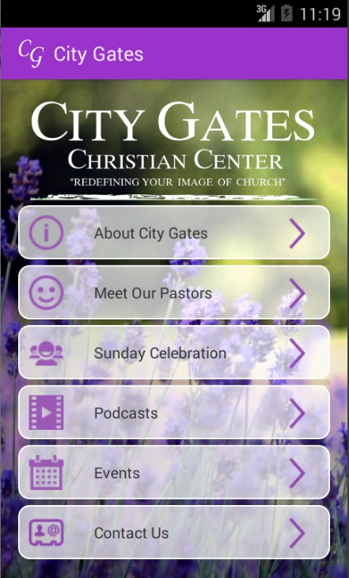

Upon tapping the ‘next’ button from the Getting Started page, the user is then presented with the City Gates Home page. It contains a list view where the user can tap any of the list items depending on the next desired page he/she wants to view. The list items are as follows: About City Gates, Meet Our Pastors, Sunday Celebration. Podcasts, Events, Contact Us. When the user taps a list item, the user will be directed to the page of the list item.

Figure 3.0 shows the City Gates Homepage that displays a City Gates Christian Center header and below is the list view. The list view is composed of list items. Each of them contains an icon, text and a ‘next’ arrow icon.

Figure 3.0

III. About City Gates

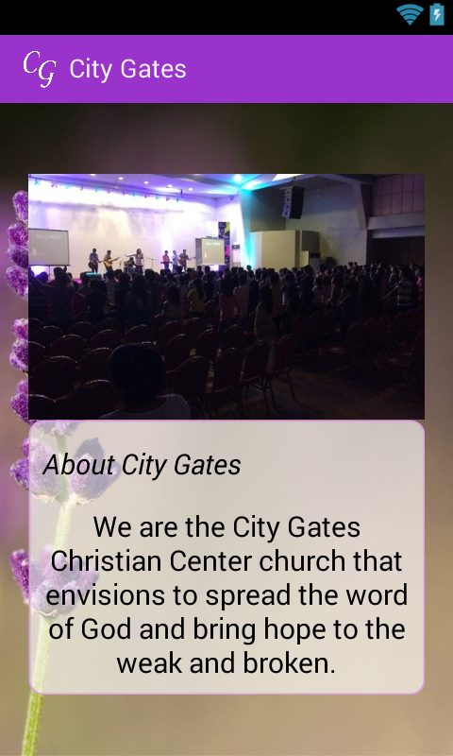

The user will be directed to the “About City Gates” page when he/she tapped the “About City Gates” list item from the “City Gates Menu” page. This page displays an image of the City Gates church and a description about them below the image.

Figure 4.0 shows the “About City Gates” page. The user can tap the built-in “previous” of his/her device to go to the previous page.

Figure 4.0

IV. Meet Our Pastors

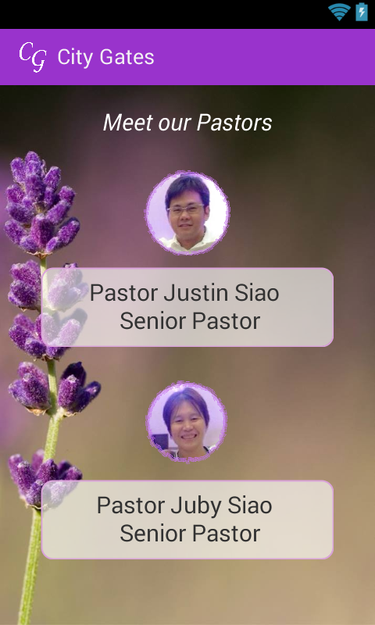

The user will be directed to the “Meet Our Pastors” page when he/she tapped the “Meet Our Pastors” list item from the “City Gates Menu” page. This page displays images of senior pastors of the City Gates church. A short description about the pastor is also displayed below each image.

Figure 5.0 shows the “Meet Our Pastors” page. The user can tap the built-in “previous” of his/her device to go to the previous page.

Figure 5.0

V. Sunday Celebration

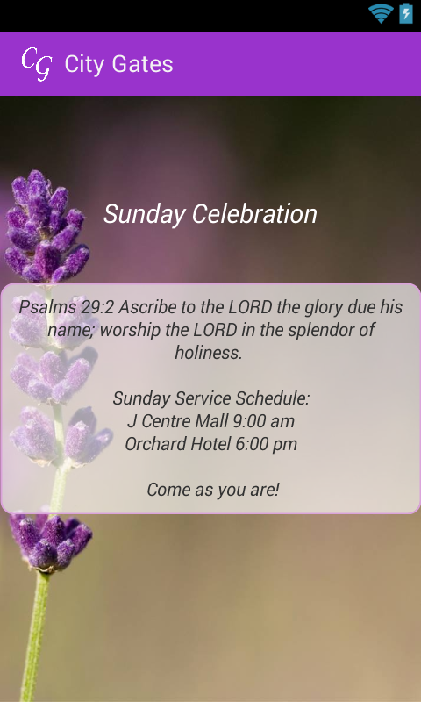

The user will be directed to the “Sunday Celebration” page when he/she tapped the “Sunday Celebration” list item from the “City Gates Menu” page. This page displays a text header and a short description about the sunday celebration of the City Gates church. The description states a bible verse, sunday service schedules and an invitation message to the user.

Figure 6.0 shows the “Meet Our Pastors” page. The user can tap the built-in “previous” of his/her device to go to the previous page.

Figure 6.0

VI. Contact Us

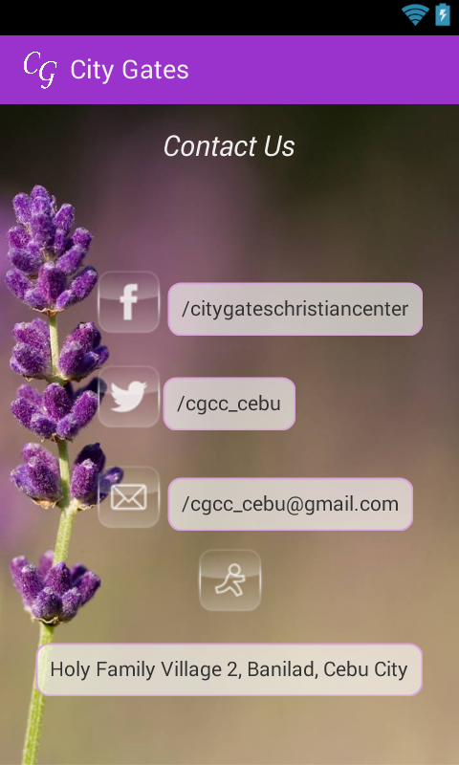

The user will be directed to the “Contact Us” page when he/she tapped the “Contact Us” list item from the “City Gates Menu” page. This page displays a facebook and twitter links, email address and the main address of the City Gates church. This allow

Figure 7.0 shows the “Contact Us” page that displays icons for each info as well as their respective descriptions. The user can tap the built-in “previous” button of his/her device to go to the previous page.

Figure 7.0